School of Computer Science and Artificial
Intelligence

Lab Assignment # 12.2

Program : B. Tech (CSE)
Specialization :AIML
Course Title : AI Assisted Coding
Course Code : 23CS002PC304
Semester : VI
Academic Session : 2025-2026
Name of Student : P.Sindhu
Enrollment No. : 2303A52207
Batch No. : 33
Date :24/02/26

Lab 12: Algorithms with AI Assistance – Sorting, Searching, and
Optimizing Algorithms
Lab Objectives:
- Apply AI-assisted programming to implement and optimize sorting and searching algorithms.
- Compare different algorithms in terms of efficiency and use cases.

Week6 - Tuesday
• Understand how AI tools can suggest optimized code and complexity improvements.
Task Description -1 (Data Structures – Stack Implementation with

AI Assistance)
- Task: Use AI assistance to generate a Python program that implements a Stack data structure.
Instructions:
Prompt AI to create a Stack class with the following methods:
- push(element)
- pop()
- peek()
- is_empty()
- Ensure proper error handling for stack underflow.
- Ask AI to include clear docstrings for each method.
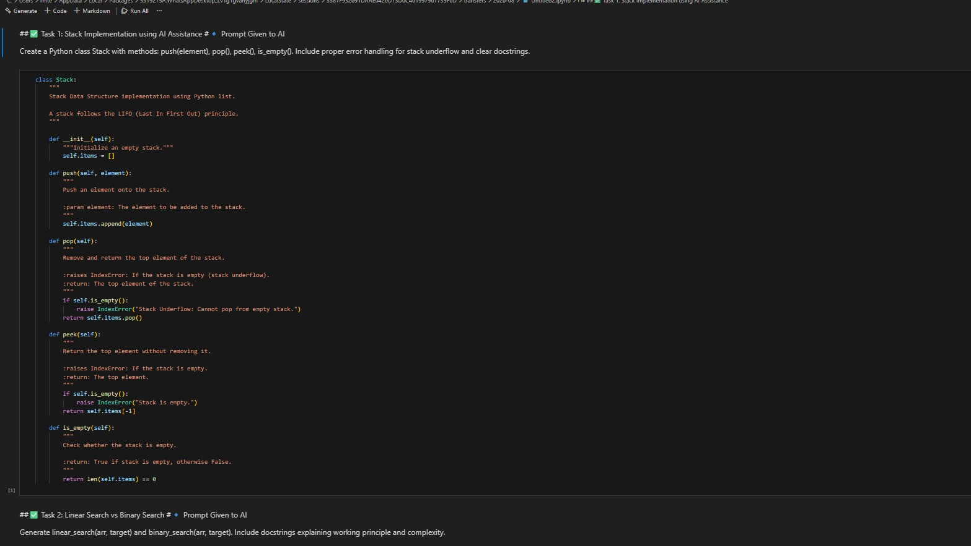
Task Description -2 (Algorithms – Linear vs Binary Search
Analysis)
- Task: Use AI to implement and compare Linear Search and
Binary Search algorithms in Python.
Instructions:
- Prompt AI to generate:
- linear_search(arr, target) ➢ binary_search(arr, target)
- Include docstrings explaining:
- Working principle
- Test both algorithms using different input sizes.
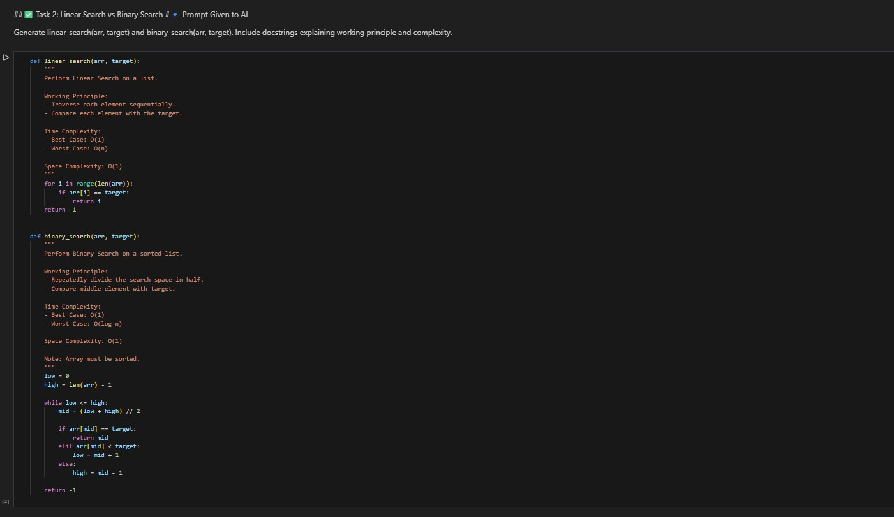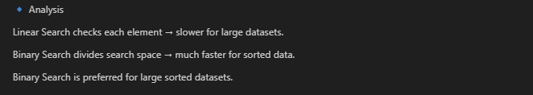
Task Description -3 (Test Driven Development – Simple Calculator
Function)
- Task:
Apply Test Driven Development (TDD) using AI assistance to develop a calculator function.
Instructions:
- Prompt AI to first generate unit test cases for addition and subtraction.
- Run the tests and observe failures.
- Ask AI to implement the calculator functions to pass all tests.
- Re-run the tests to confirm success.
Expected Output:
- Separate test file and implementation file.
- Test cases executed before implementation.
- Final implementation passing all test cases.
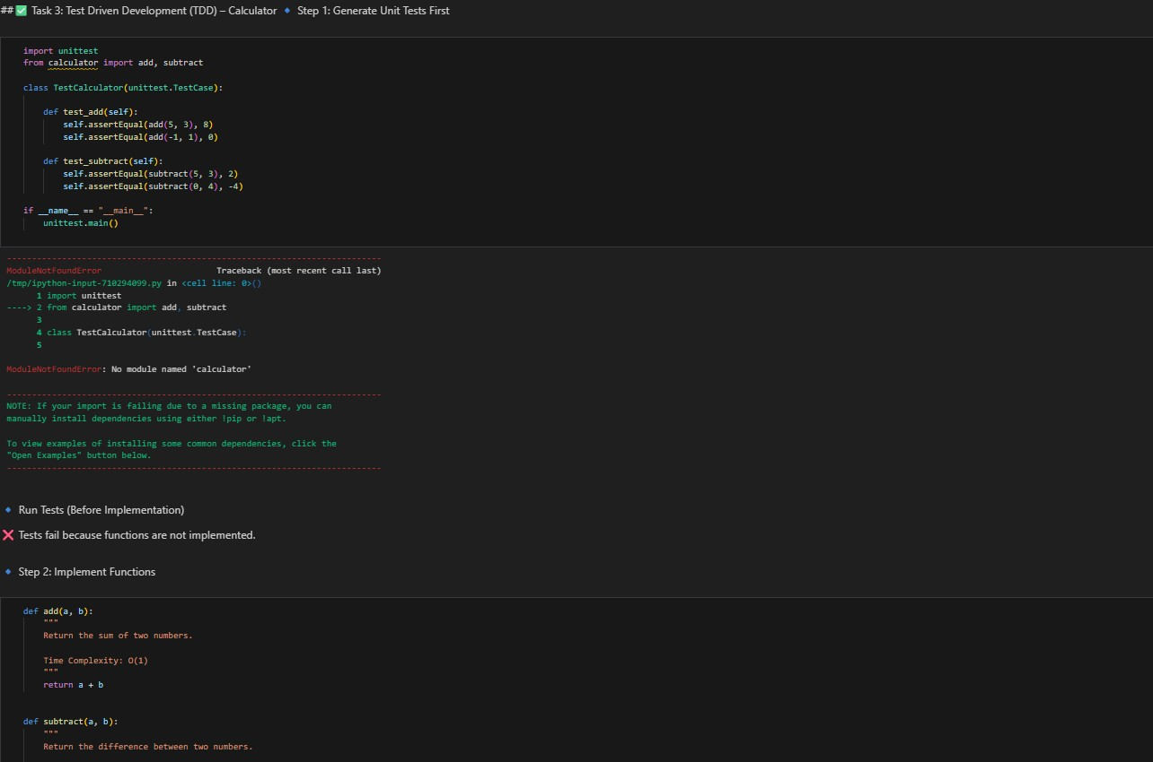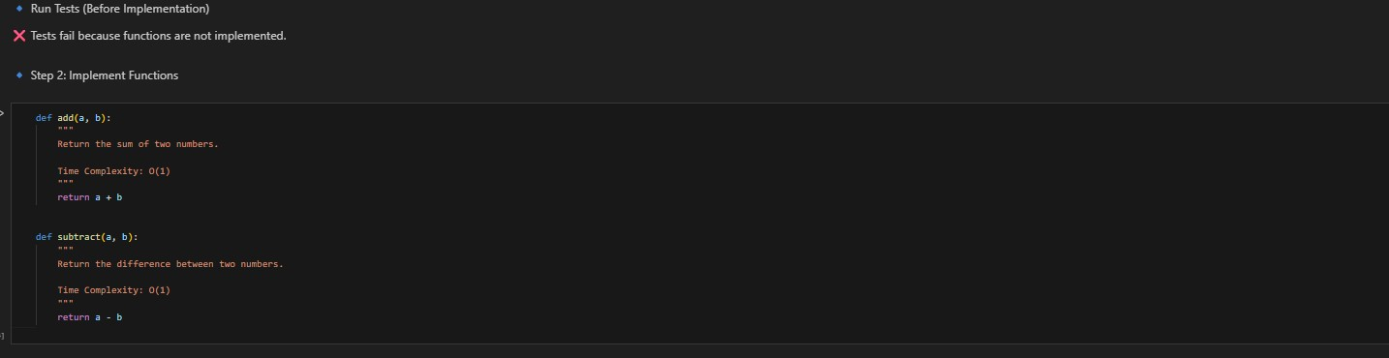
Task Description -4 (Data Structures – Queue Implementation with
AI Assistance)
- Task:
Use AI assistance to generate a Python program that implements a Queue data structure.
Instructions:
- Prompt AI to create a Queue class with the following methods:
- enqueue(element)
- dequeue()
- front()
- is_empty()
- Handle queue overflow and underflow conditions.
- Include appropriate docstrings for all methods.
Expected Output:
- A fully functional Queue implementation in Python.
- Proper error handling and documentation.
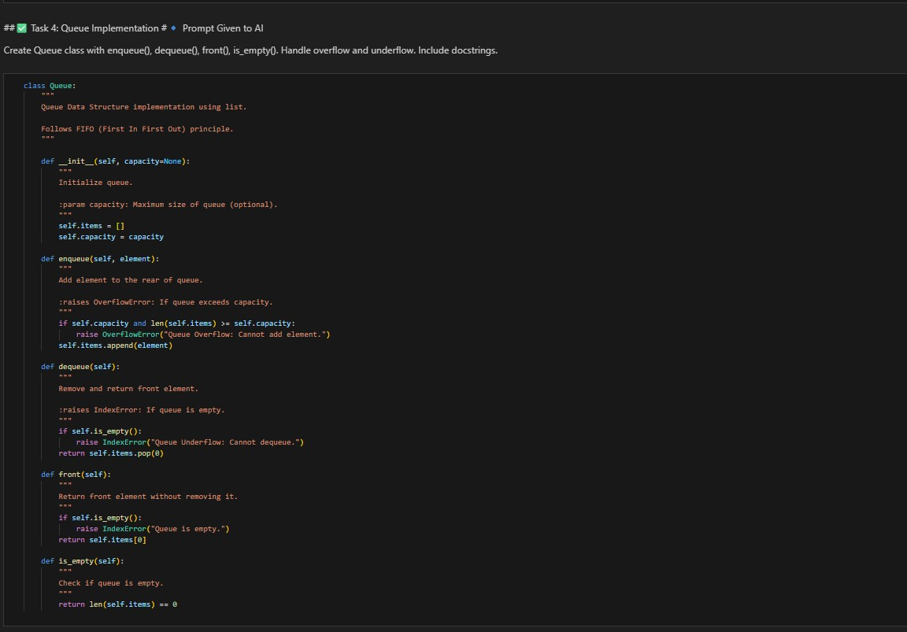

Task Description -5 (Algorithms – Bubble Sort vs Selection Sort)
- Task:
Use AI to implement Bubble Sort and Selection Sort algorithms and compare their behavior.
Instructions:
- Prompt AI to generate:
- bubble_sort(arr)
- selection_sort(arr)
- Include comments explaining each step.
- Add docstrings mentioning time and space complexity.
Expected Output:
- Correct Python implementations of both sorting algorithms.
- Complexity analysis in docstrings.
